ISSUE #8: AD
- Add Reference
- Fill out the mandatory fields
- Save Reference
- Edit the Reference
- Edit Name Let Say
- Save Reference
- ISSUE: You should see application will not response and chasing circle remain on screen

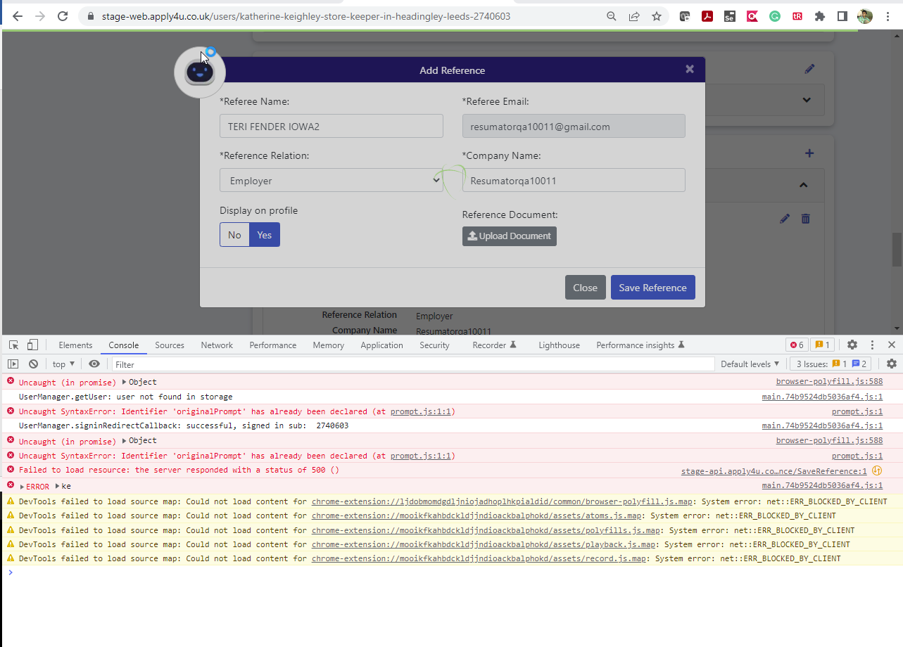

ISSUE #10: AD
- Add Reference
- Submit Request
- Open Request Email
- Open Link and send requested reference
- With you user profile refresh and see reference is added
- Edit the filled reference example Turn On/Off the Display on profile
- Save
- ISSUE: Chasing circle remain on screen

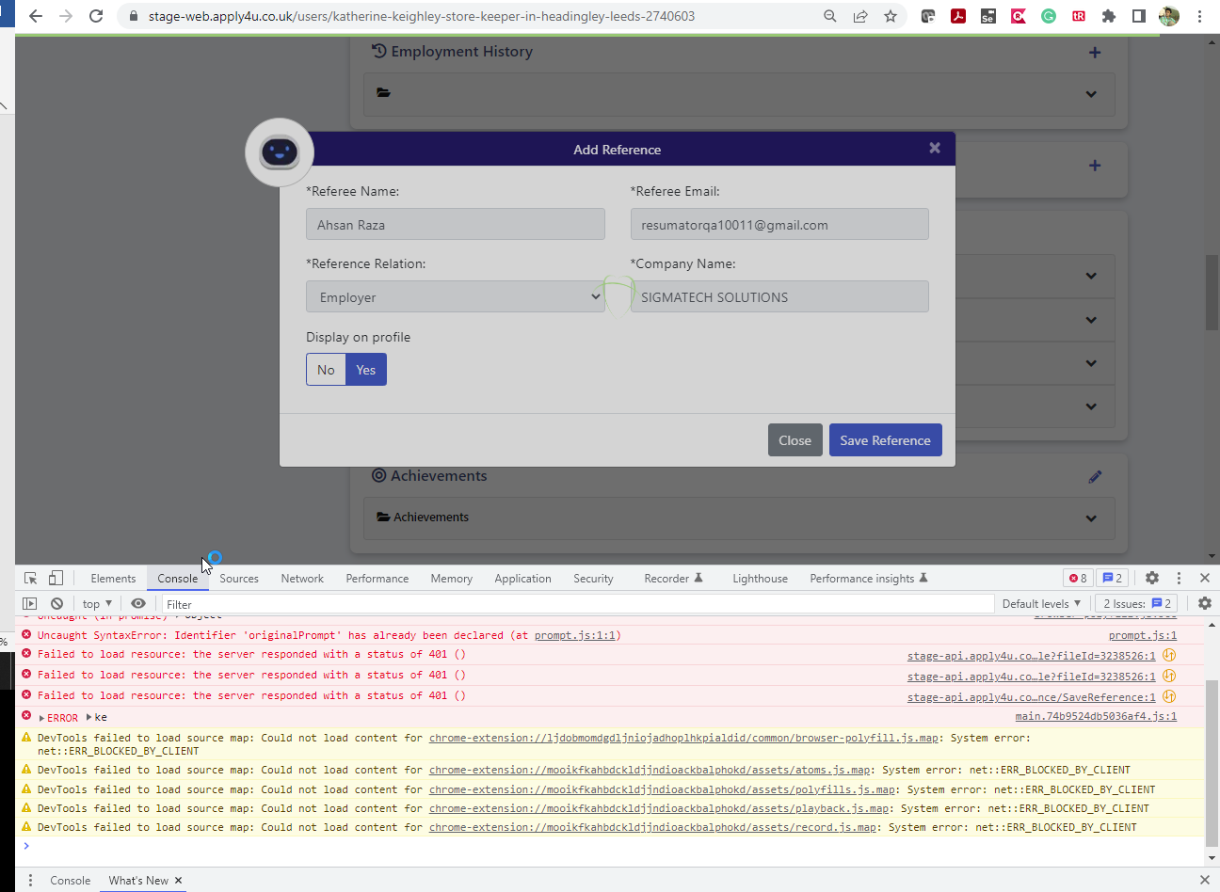

ISSUE #11: (On First cycle replicated this after logout and login not able to replicate) AD
- Add Reference
- Submit Request
- Open Request Email
- Open Link and send requested reference
- With you user profile refresh and see reference is added
- Now add another reference and enter the same email address same as step #2
- Save
- ISSUE: Chasing circle remain on screen

