Issue 1:
Job card display needs to be fixed.
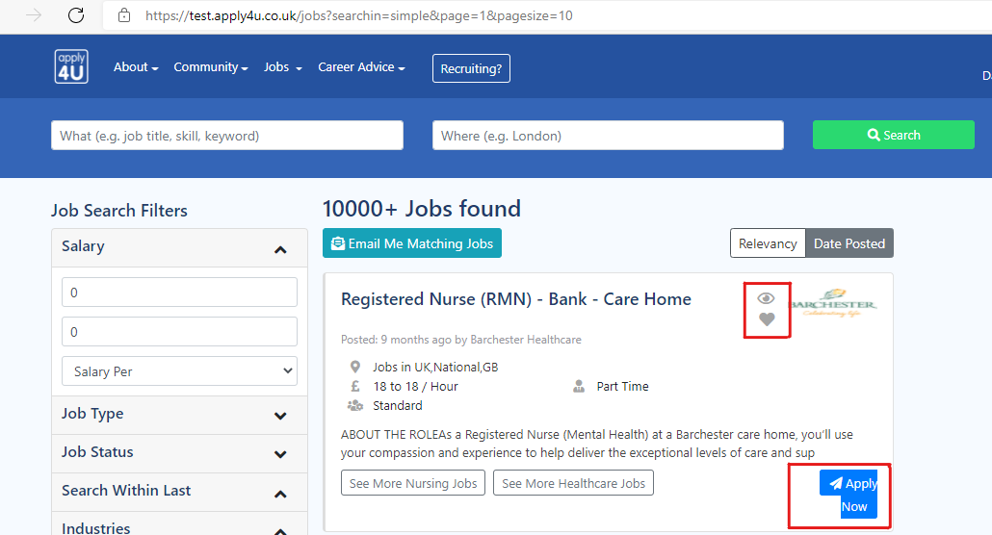

Issue 2:
Apply on job, you will see the page keeps on loading.
However, application has been sent and saved to applications.

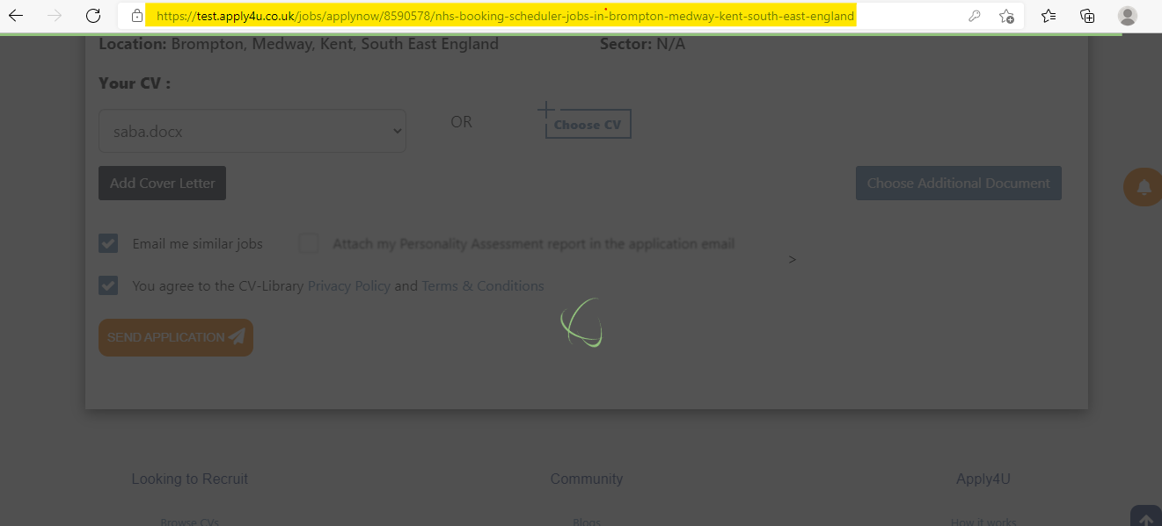
Issue 3:
Area: CV card
SEE MORE button should change to “see less” state.
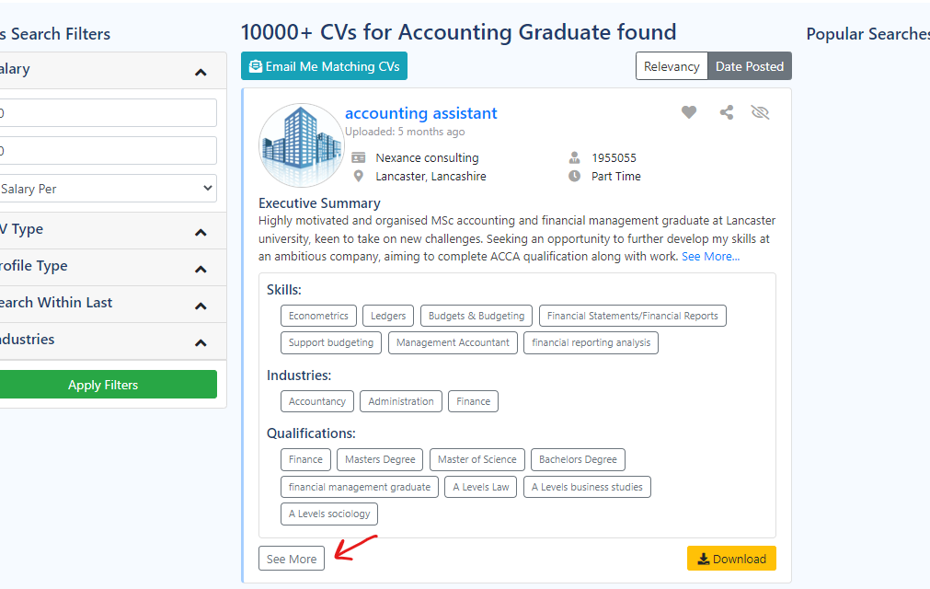
Issue 4:
Skill do not get displayed on posted job page.
However, it appears on job detail page.
