ISSUES and Findings REVIEW CV

ISSUE #1: AW-3987
- Fields Heading. - ‘Change CV’ should be displayed like the other fields with the word in between the green lines - RR

Please verify your details - Are we Okay with heading – Color/Font?
- Checkboxes color – are we okay with the checkboxes color?
- Text “Your CV was found online on (29/8/2023)” – See the text color - Are we Okay?
- Download CV button color -?
- “Remove my CV & details” – are we okay with color label?

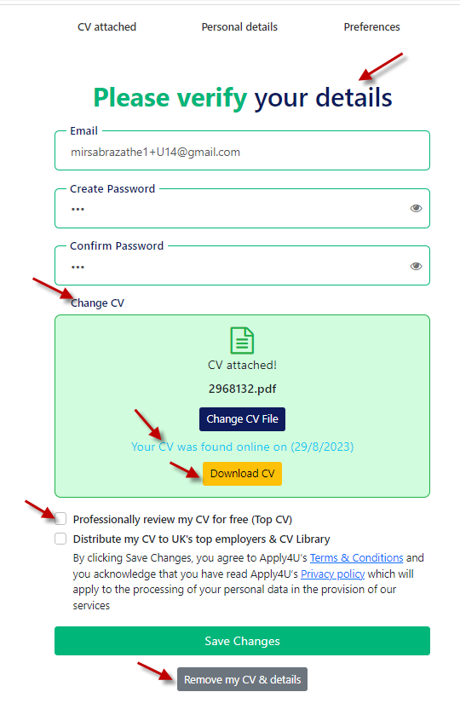
ISSUE #2: AW-3988
- CV Review Screen, Click on, the Remove my CV & details button, You will see Do you want to unsubscribe? Screen.
  - The heading color does not match with our new theme
  - Unsubscribe – The button color does not match with a new theme
  - Also, see the email field or text under the heading – Are we okay with the current placement and design?

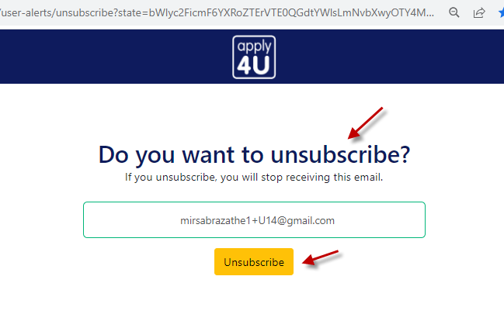
ISSUE #3: AW-3989
- CV Review Screen, click on, remove my CV & details button, You will see “Do you want to unsubscribe?” Screen, Click the Unsubscribe button.
- You should see the screen “You have unsubscribed successfully”
  - Any design changes on this screen? I see only this text on the whole screen.
- Suggestion – I think there should be buttons or links to redirect the user on our home screen or like the Sign up / Sign in button etc.
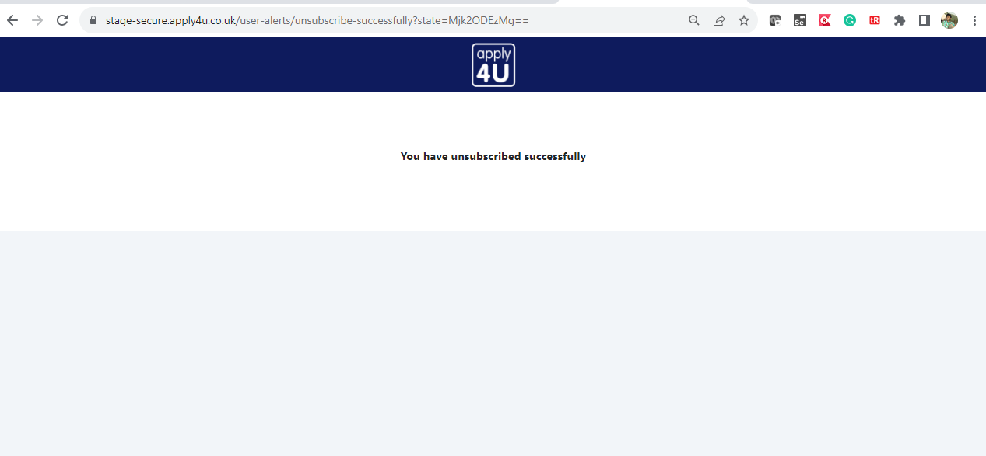

ISSUE #4: AW-3990
- When you unsubscribe and then user access the same link – You will see the below screen.
  - Any design changes on this screen?
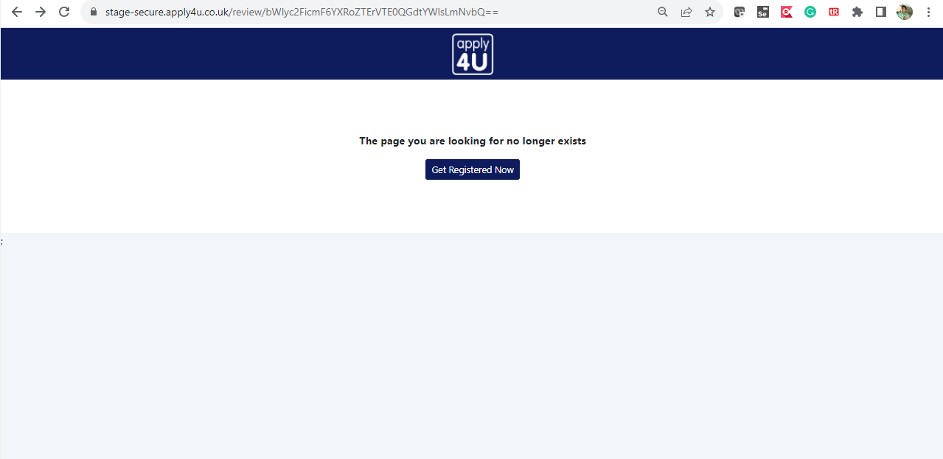

ISSUE #5: AW-3991
- Post Code should be Postcode – Remove space. - Needs changing – RR

- See the new theme and live screenshots – are we okay with the new design?

  - Now each field is in a new line but on live two fields are aligned horizontally.

New Theme:
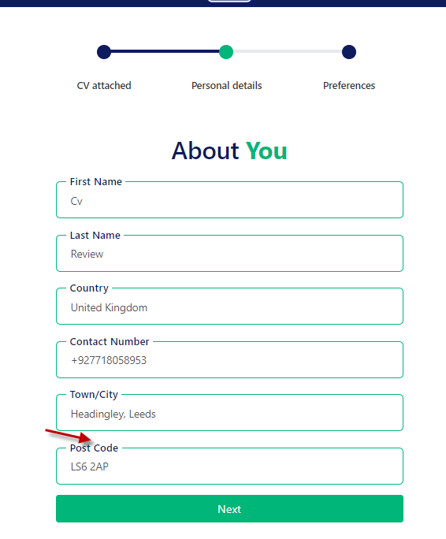
LIVE:
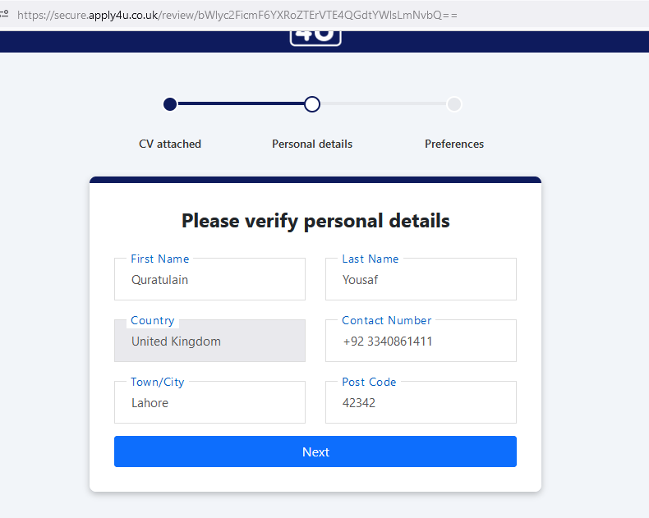

ISSUE#:6 W-3992
- When you change the CV in the review process then within the personal details screen First and Last Name displays as CV/Review

