Registration process addition –Apply on my behalf – Screened and Apply
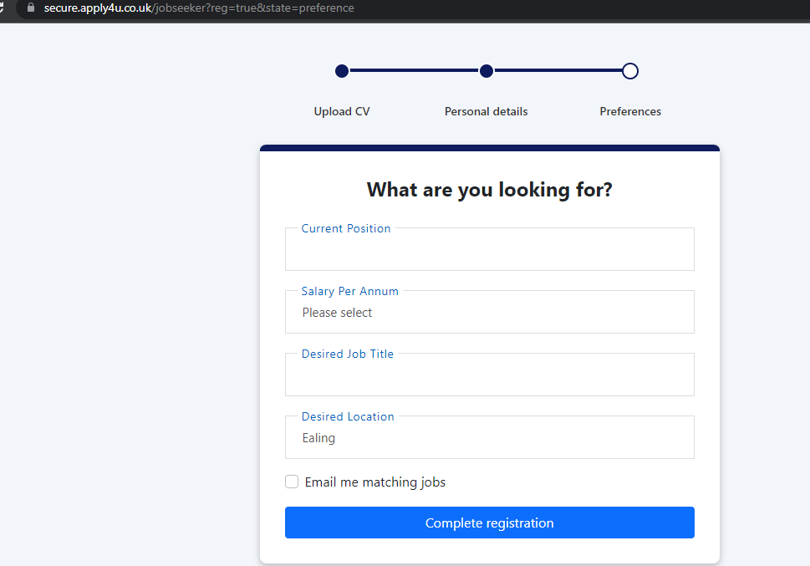

To add to the page in screenshot above:
Suggestion –
To add box into jobseeker registration flow ‘preferences’ page that candidates can tick for us to ‘apply on their behalf’.
How it could potentially work -
Another Tick box underneath ‘email me matching jobs’ saying ‘ Apply for Jobs on my behalf – Apply4u’.
If the user ticks this box then after they click on ‘complete registration’ there is a pop up box that appears that tells them the following “By selecting for us to Apply on your behalf we’ll start to apply for around 10 jobs a day that are matching what you’re looking for until you tell us to stop or until we can’t find any more relevant jobs!
To complete this we need the following additional details:
-What distance around DESIRED LOCATION are you looking? (radius box with usual numbers as per other filter boxes)
-Are you looking for this full time, part time, contract or all of the above?
-Are you open to similar matching jobs?”
They need to fill out all of these boxes to proceed otherwise it will not continue and show up in red.
Within this pop up there should also be a cancel button that the user can then click on which will then untick the ‘Apply for Jobs on my behalf – Apply4u’ automatically and take them out from the pop up.
If they click ‘confirm’ from the pop up box then it will take them through the normal registration process as well as doing the following process underneath for the admin panel.
Admin Panel -
Filter needs to be added to the admin panel if the user has selected to go for ‘apply on my behalf’.
Filter needs to be added anywhere in the search filters box shown in below screenshot for ‘Screened and Apply’ with simple ‘Yes’ or ‘No’ Filter to switch between.
Then there also needs to be added another green or red box correlating to ‘Yes’ or ‘No’ in the line next to where the user profile has ‘TotalJobs’, ‘jobg8’, ‘Job Alerts’ etc.
This button will simply be able to turn Green or Red for the UK Team and Support Team to be able to switch between easily to communicate if we are doing actions on this users behalf.
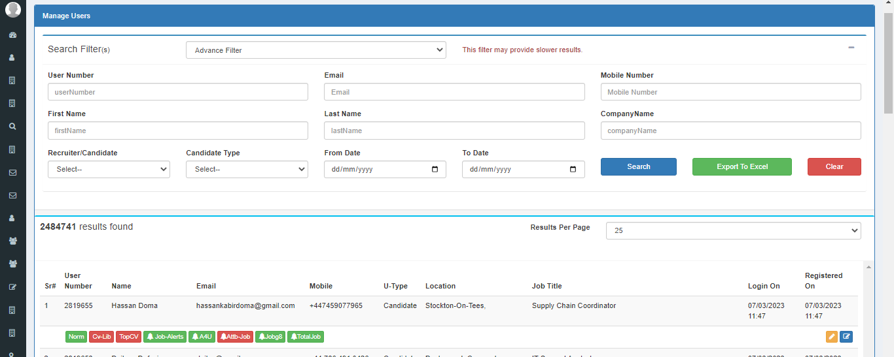
Future use case –
-The system then automatically applying to jobs that are 80% matching or above when they’ve selected the ‘apply on my behalf’ which can be turned off at any point through the green/red box mentioned above.
Additionally, questions to answer:
In the first screen shot for ‘preferences’ page why are we are only allowing salary per annum on there? Will that deter users that want a ‘per hour’ job?
What is the point of having the current positon in there when there is desired job title?

