ISSUES Recruiter Registration

ISSUE #1: AW-3937 - Richard's Feedback Needed
- “Create your account” – Should say “Set up your account” like Jobseeker?

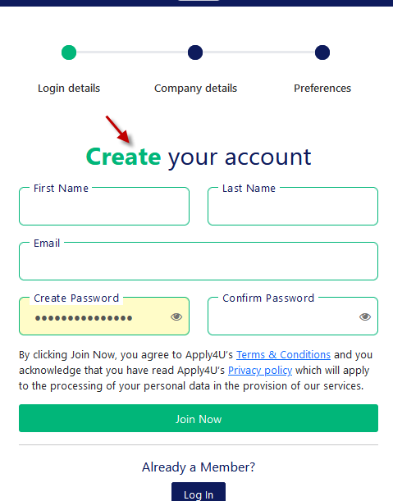
JOB SEEKER
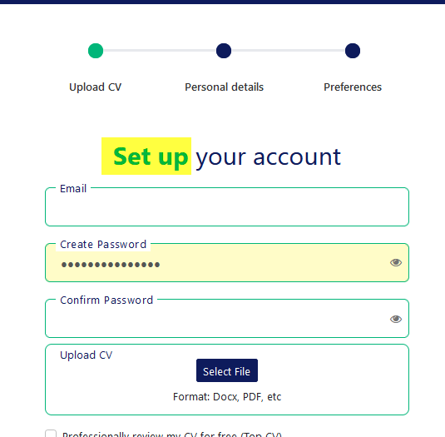

ISSUE #2: AW-3938
- Register Recruiter Account – Login Details
  - Terms & Conditions
  - Privacy policy
- Click on links this will open up in a new tab.
- Now on a new tab click on the Register button.
- ISSUE: Clicking the Register button should redirect the user to the new theme, right now it's redirecting to live. Please change this URL for the stage.
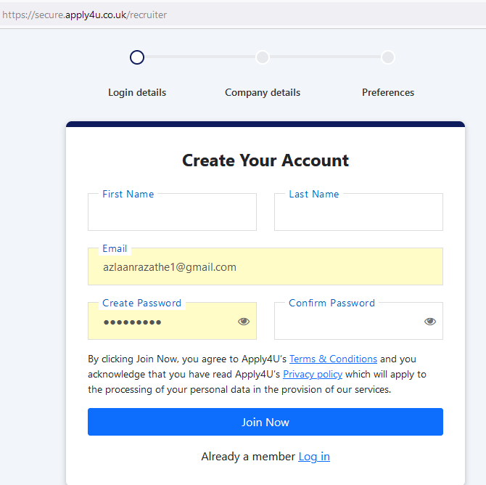

ISSUE#3: AW-3939
- Email Label overlap issue when you enter an incorrect email address and tab out from the field.

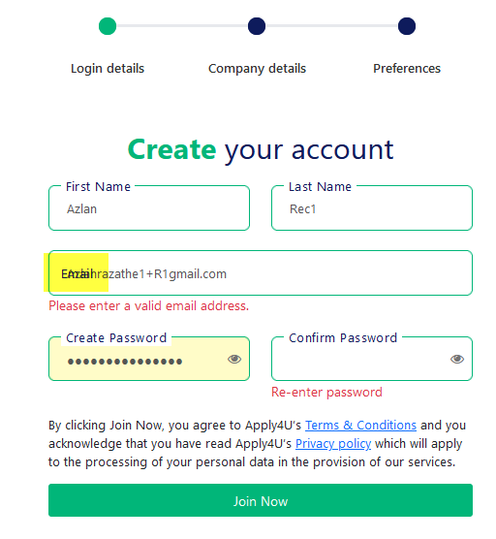
ISSUE #4: AW-3940 – Richard Feedback Needed
- Based on Job Seeker Feedback
  - Login button color and size - Colour is ok, size should be half the size (width) and same height as the Join now button - RR
  - Question mark in front of already a member - Remove the question mark - RR

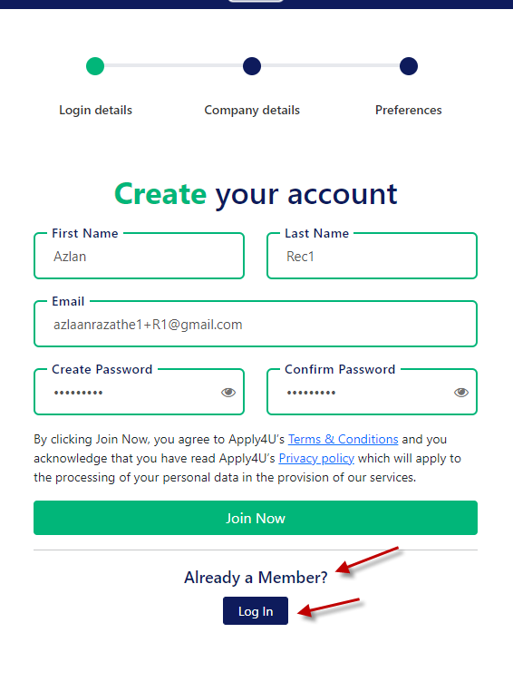

ISSUE #5: AW-3941 – Richard Feedback Needed

- Company details – Colors scheme do match as per job seeker.
  - ‘Company’ heading color – Should be Blue
  - ‘details’ – should be Green.
  - See the Font size and give you feedback?
  - Don’t you think so header should be “Details” instead of details?
- Upload company logo -label- should be displayed like the other fields with the word in between the green lines - RR
- Upload company logo -label- color and font size issue
- Upload icon – Color issue – Don’t you think so it should also be blue like fields labels color?
- Next Button color does not match with our theme color.
- Upload company logo – Label – Don’t should think so should be “Upload Company Logo” for consistency?
- Select Company Logo – button label – can we now change this to Company Logo?

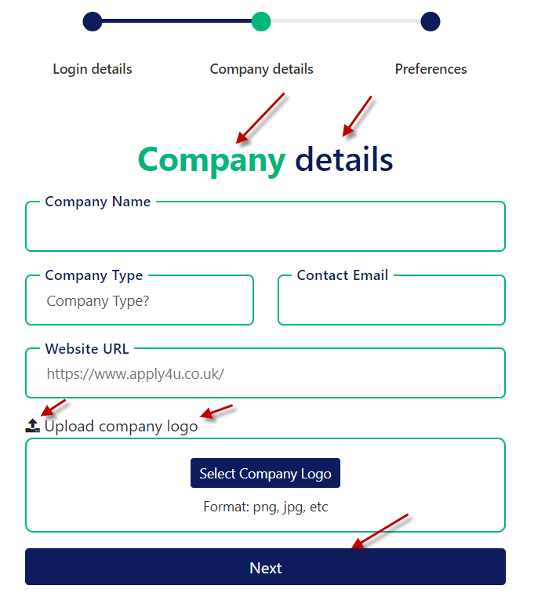
ISSUE#:6 AW-3942
- Company Name Search
  - Boundary lines should match our theme color.
  - The horizontal boundary line almost touches with the Upload company logo boundary line – it has some space right now looks like a kind of overlap.
  - Company Type drop-down Boundary lines should match our theme color.
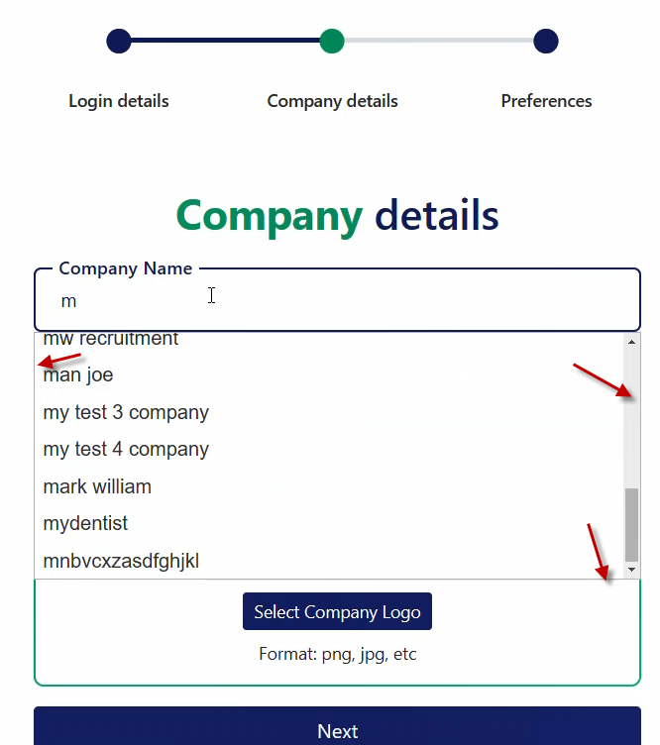
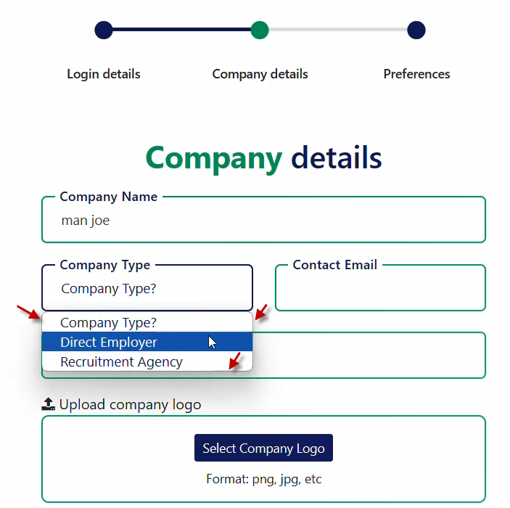

ISSUE #7 AW-3943
- Company Email label overlap issue when you enter incorrect email address.
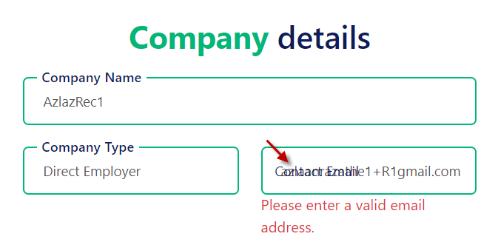
Suggestions
- When you select a logo then text changes to “Company logo selected successfully”
  - Any color scheme does you want to apply to this text?
  - Change Logo File – Button Label – Do you want to shorten this label? Like Change Logo or Change File?
  - File icon as well – any suggestions

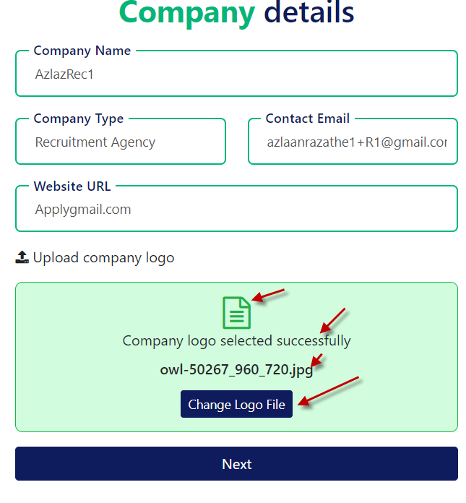

ISSUE #:8 AW-3944 Richard's Feedback Needed

- Header Color scheme does not match with the new theme.
  - Suggest the color of each word and also the font size
- Complete registration button color does not match our new theme.
- Complete registration button label should be Complete Registration – registration R should be in caps.

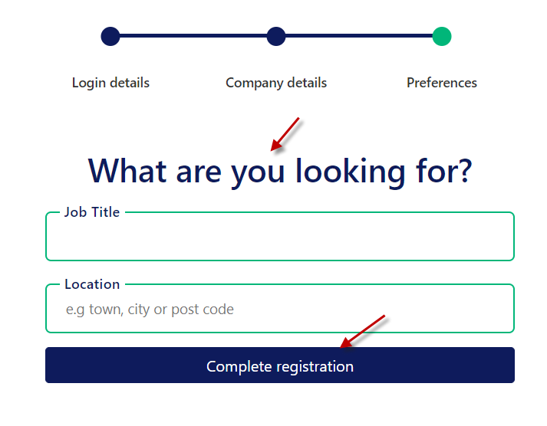

ISSUE #:9 AW-3945
- Recruiter Registration process completion – Application redirecting me to the Sign in Screen and live – default sign in and redirecting me to the dashboard
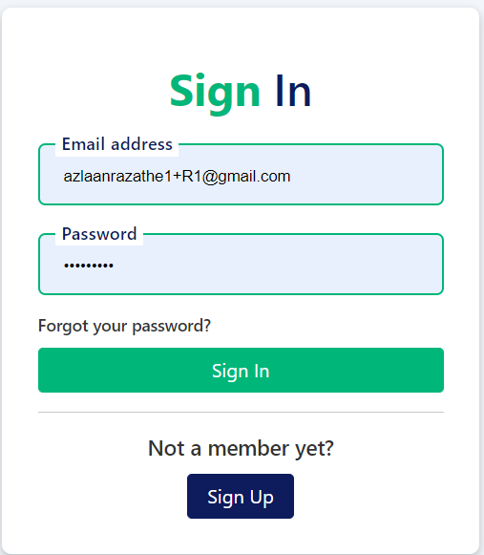

ISSUE #10 Same as Live AW-3946
- Recruiter Site – Without Sign in
- Visit About Us menu Click on - Our Story action link
- This will redirect you about page
- Click on Join The Community button
- This will redirect you to the Sign In
- ISSUE: Its an old theme, should be the new theme
- ISSUE2: Clicking Sign up button should redirect the user to the Recruiter registration process.

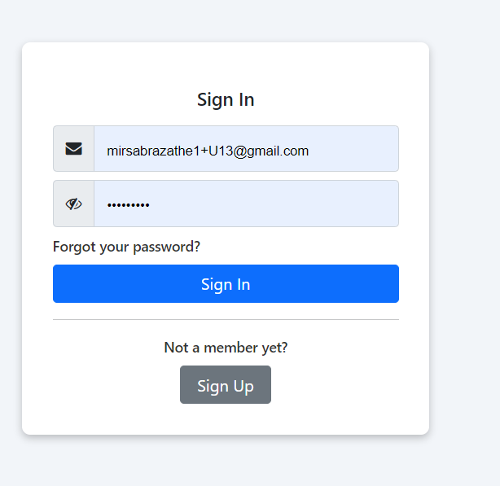
ISSUE #11 Same as Live AW-3947
- Recruiter Site – Without Sign in
- Visit About Us Menu Click on - Our Story action link
- This will redirect you to the page.
- Scroll down and click on Find out more button.
- This will redirect you to the our-technology page.
- Click on the Register button from header.
- ISSUE: Should redirect you to the new theme

ISSUES and Findings Recruiter Sign In Screen
ISSUE # 12 AW-3948
- Sign In Screen – Eye icon is missing. Live have but on live eye icon is not functional.
Please fix, also Eye icon needs to be right aligned like Registration form. Please ensure this is consistent wherever we show the eye icon - RR
- Field Label is “Email address” – Don’t you think so should be “Email Address”? Please confirm with Irfan - Yes, Capital A on Address - Wherever we have a form it should be Captial letters at the start of each word - RR

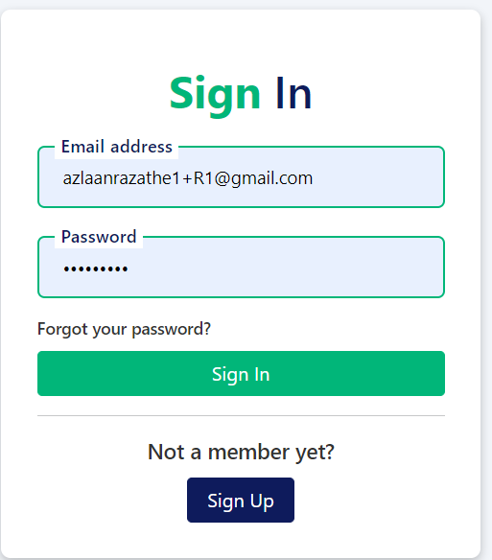

ISSUE #13 AW-3949
Placeholders are missing within email and password field. - Needs fixing - RR

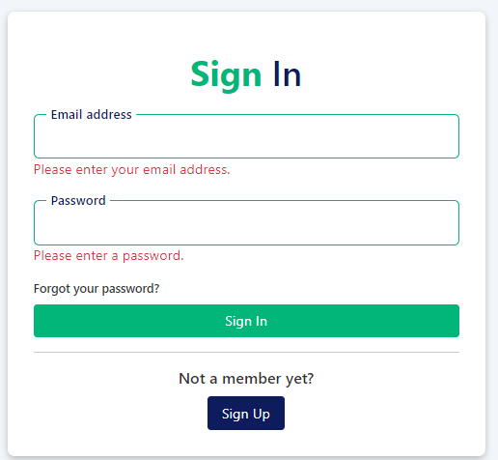

ISSUE #14 AW-3950
- Forgot password screen.
  - Header does not match with new theme color. - Agree, also change Forgot Password to - Forgot Password
  - Email label should be Email address like on sign in screen.
Agree dont forget cap A for Address - RR
- Placeholder is missing – Also on live – see if we can add. - Agree RR
- Send reset link button – Don’t you think so should be green? - Agree also ensure consistent width and height as the rest of the buttons - See comment made on issue 2
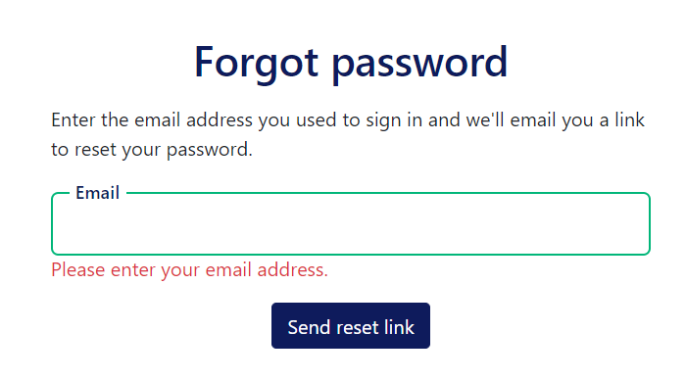
ISSUE #15 AW-3951
- Forgot password screen.
  - Correct the Reset link success message. - Agree Change word send to sent - RR

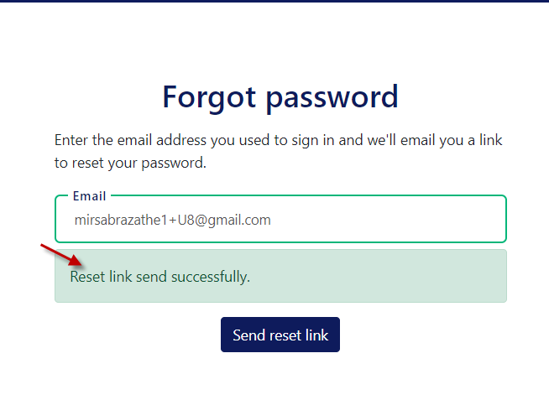

ISSUE #16 AW-3952
- Forgot password screen.
  - Label overlap when you tab out from the field. - Needs Fixing RR
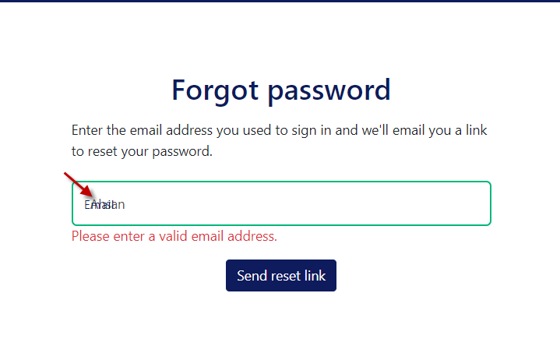
ISSUES and Findings Job Seeker Reset Password
ISSEU #17 AW-3953
- Header does not match without new theme color.
Richard’s feedback:
- Make the 'Reset' text the same green we are using everywhere and bold
- The Reset Password button should have a cap P for Password
- Make the button color Green and the same style as the rest of the buttons (I've attached an example).

