New Registration Flow
Part 4
If the user has ticked to Distribute his CV, after filling the registration form, he will get the CV Distribution page. Here, we also need to make some fixes as reported by Irfaan:
- Logo is different from the one in the previous page… Use same logo image as Register page
- Title change = Share your … change to “Share your CV with UK’s Top Employers and Jobsites”
- Give more space between the logo and text.
Test case failed
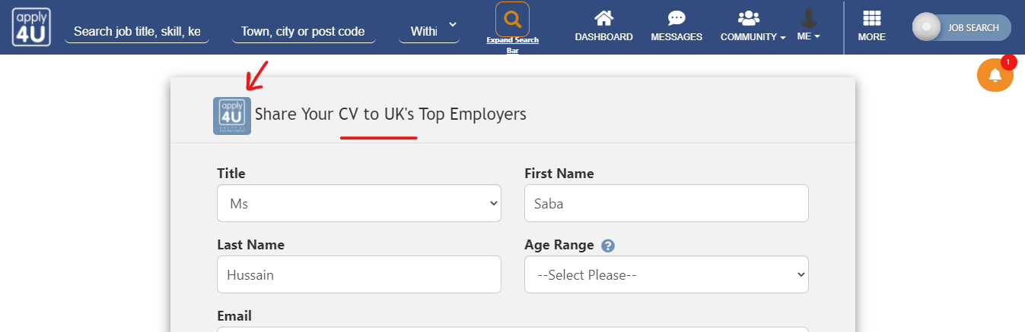
- –Select Please—
i. Should be – Please Select –
ii. Make it Red in colour so they can easily see it
Note: Not sure what is the latest requirement for this point. However, If it’s the same as explained above I cannot see the change.
- Phone +44 should be on the same line as the number not on next. So +44 a small grey box on the left of the number.
Test case passed
- Currency = Default Pound Sterling (GBP)
- Driving Licence = default Full Licence (Own Car)
Test case failed
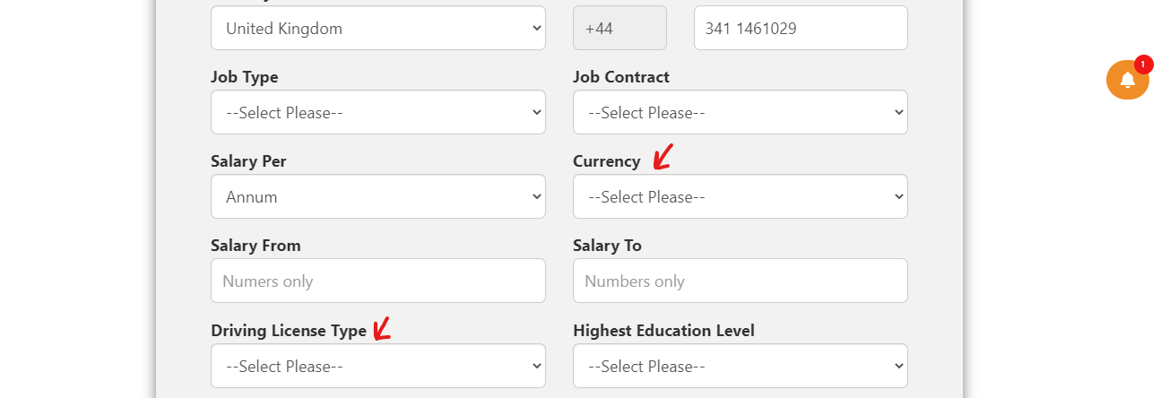
- Change button to Distribute My CV
Test case failed
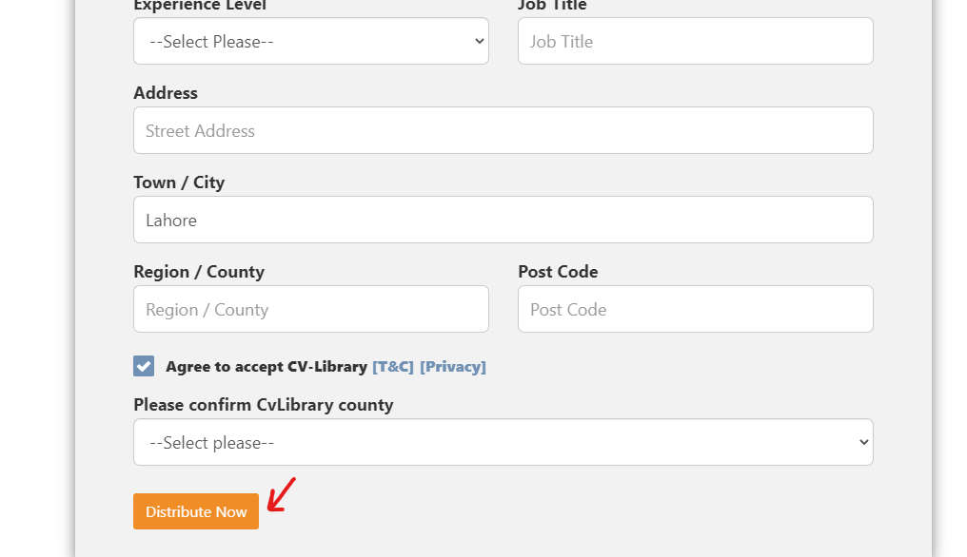

Note from Iason: I just want to remind you that after he submits the distribution form, make sure that he lands on the Dashboard page, and not the Thank you page. Same for the registration form. There should be no more landing on the Thank you page.
Test case passed

