1:- Difference in page names

2:- Blank statement validation missing on Edit F.S Formats button screen

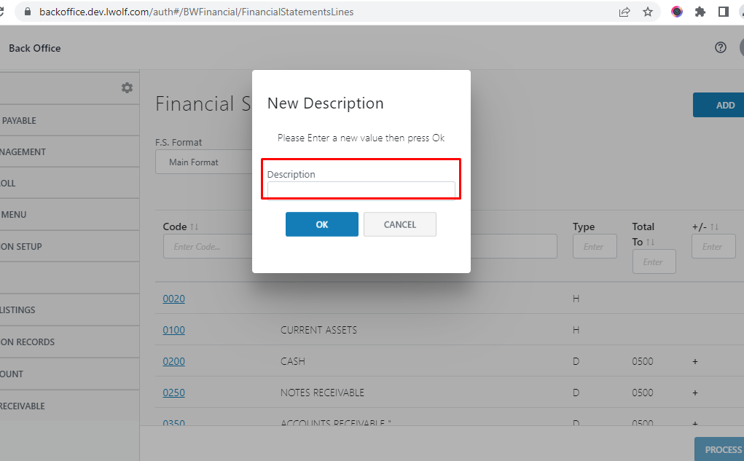

3:- Select F.S. Format screen title missing on web app

4:- Delete operation not working on web app on Edit F.S Formats button screen

5:- On clicking Cancel button the system is taking the user to Financial Statement Format screen instead of Edit F.S Formats button screen

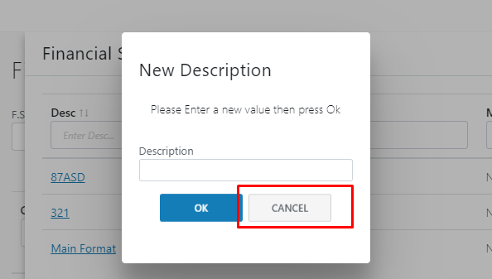

6:- GUI Issue

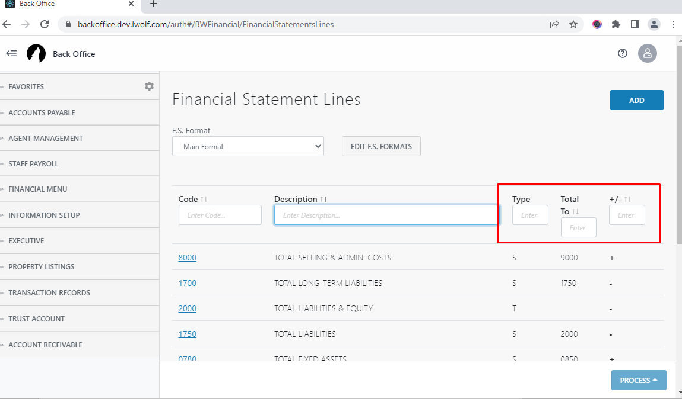

7:- Empty space validation not handled on Add button on web app

8:- Difference in page names

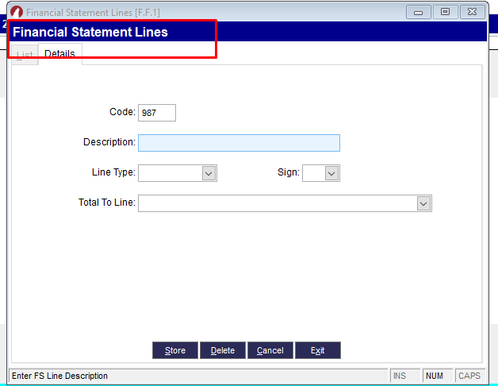

9:- Edit function not working. Instead of editing existing record the system is add a new record with updated name

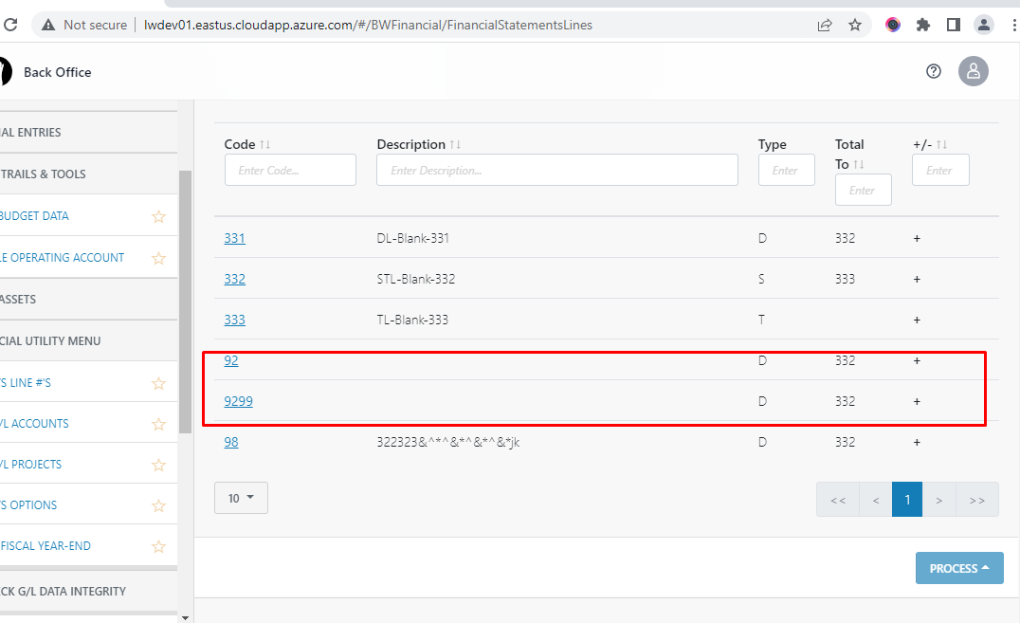

10:- Delete function not working.

11:- Add new button General Ledger Accounts screen is different on web app than desktop app

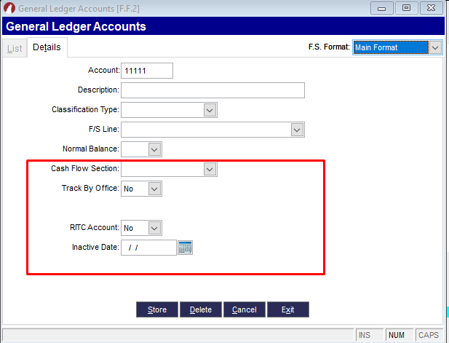

12:- Space validation not handled on description field on Add button

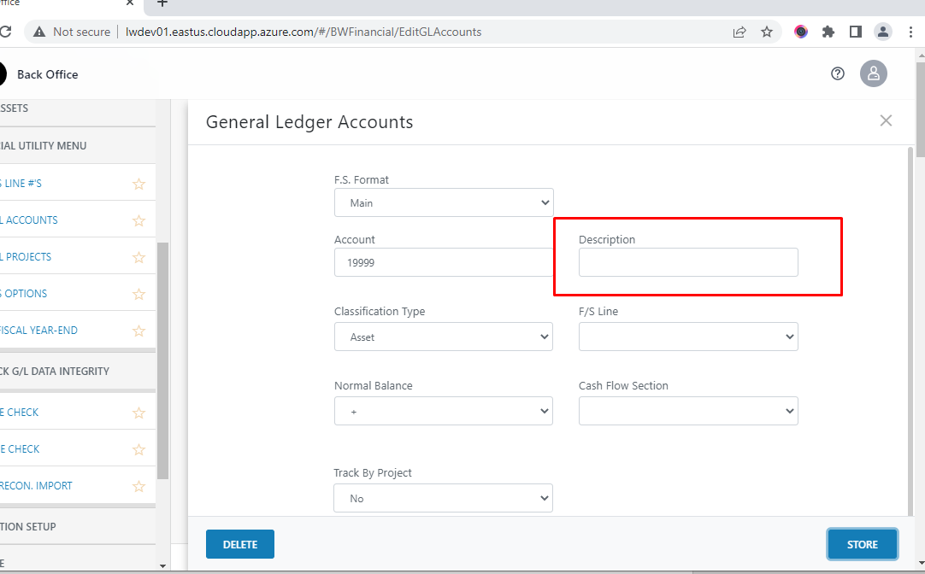

13:- Update function not working on records of Edit G/L accounts Screen

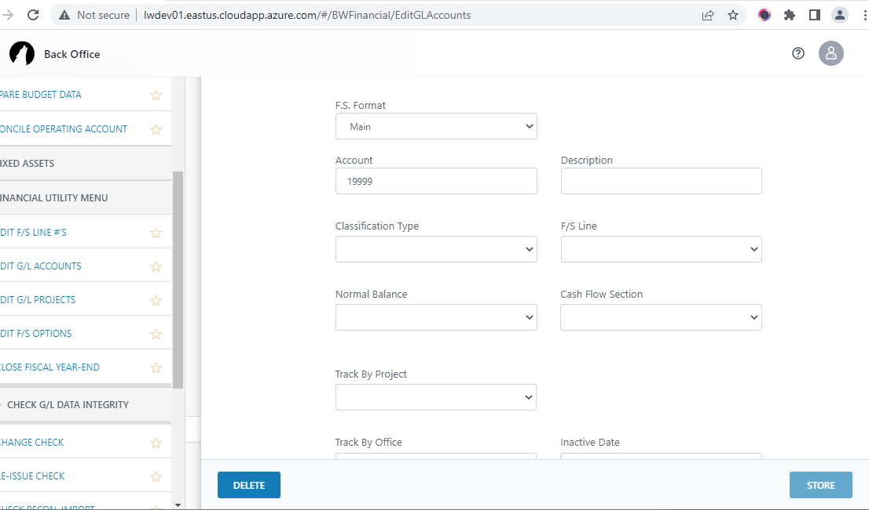

14:- Show Inactive check box seems not working on Edit G/L accounts Screen

15:- Space validation not implemented on Add button screen on Edit G/L Projects Screen

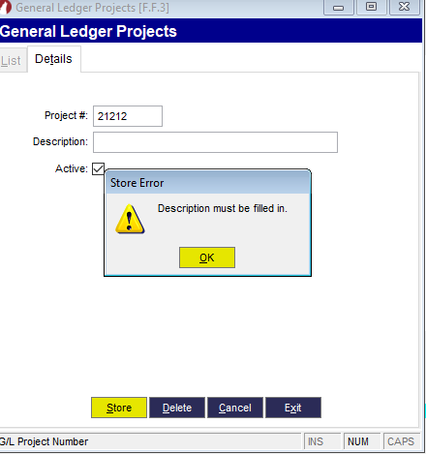

16:- Data word missing on alert message on Add button screen on Edit F/S Options Screen

