ISSUE #1 (Approval required)
- Open the link
- Enter password and Click Save changes button and shifted over to Personal details (Leave as is)
- I can see within Admin candidate is changed to normal candidate
- Access the same link that you received via email
- ISSUE: The page you are looking for does not exist screen should display. Right now, seeing Personal details screen.
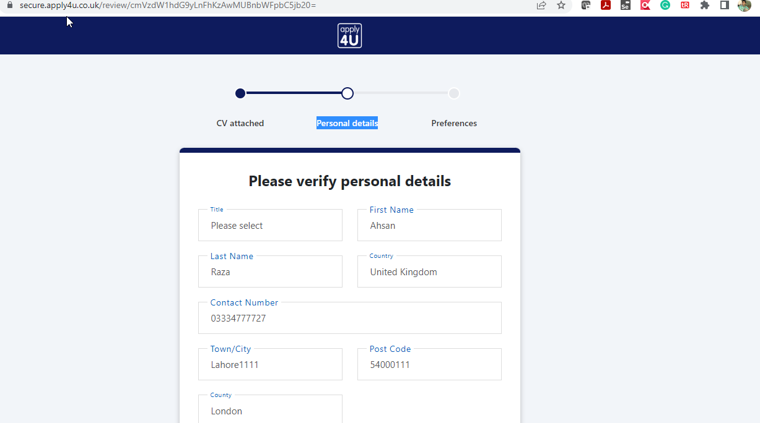

ISSUE #2: (Location mapping with CV-Library not yet done)
Previous state: Note the Location
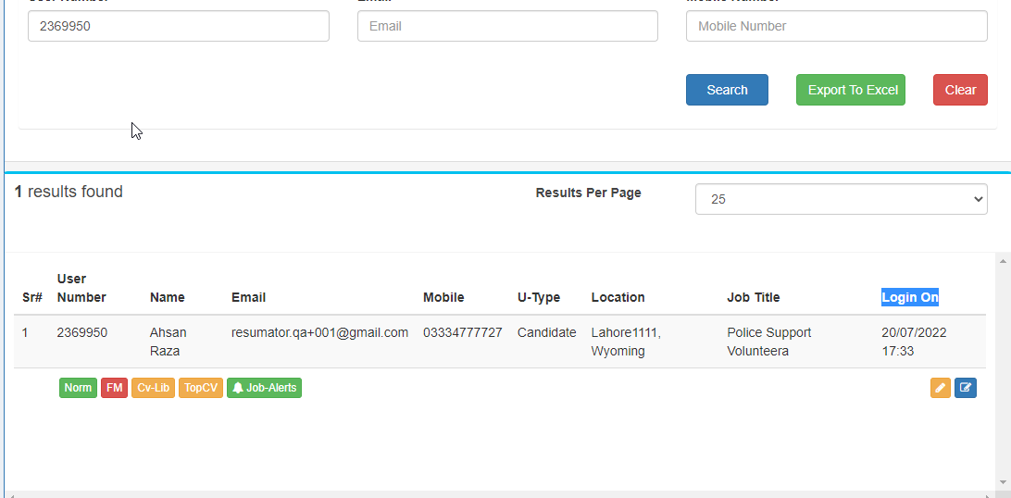
- Now via link I completed the registration
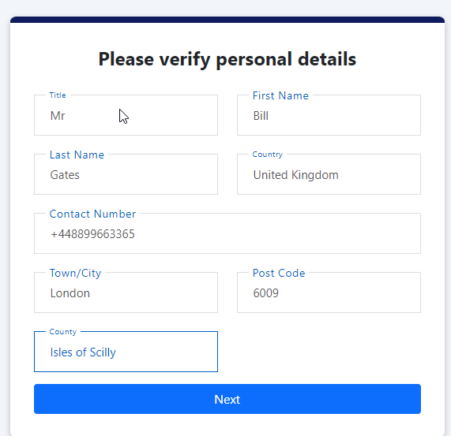
After Completing the registration:
- ISSUE: You should see Location still shows Wyoming within the location field
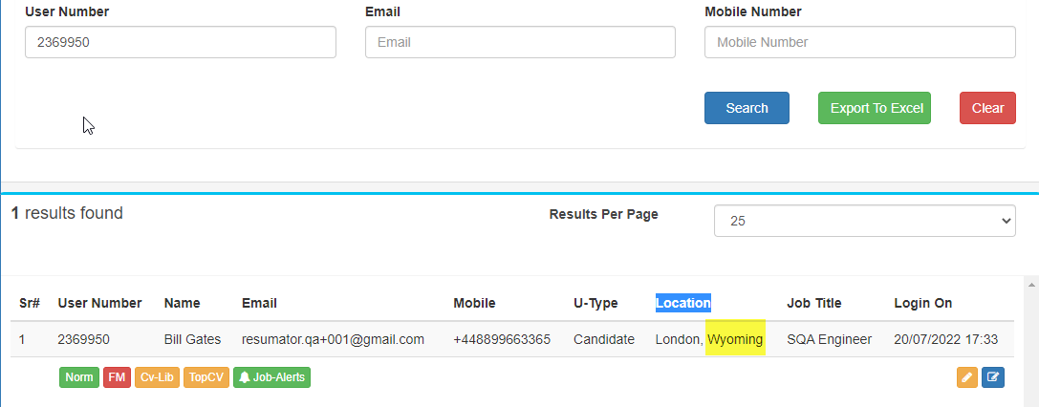
ISSUE #3: (Understanding issue)
- Email link
- Enter pass and check the TOP CV checkbox
- Complete the registration
- ISSUE: TOP CV remain yellow and should turn into green

ISSUE: 4 (Fixed)
- ISSUE: Desired Job Title is not updated within profile after completing the registration

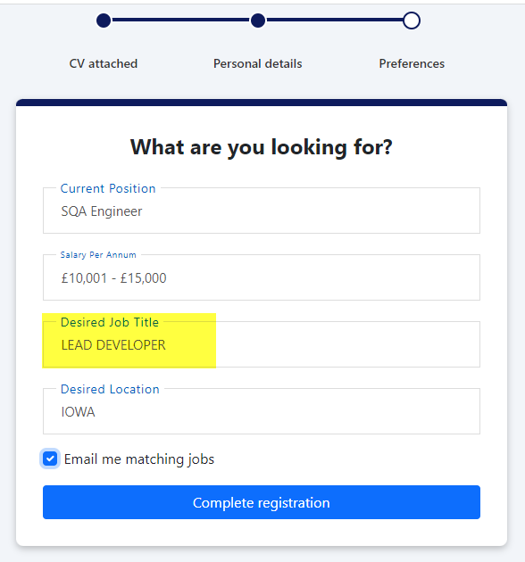
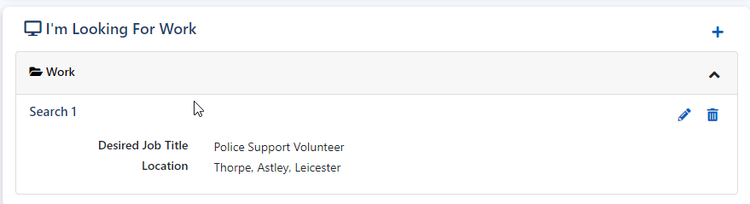

ISSUE : 5 (Fixed)

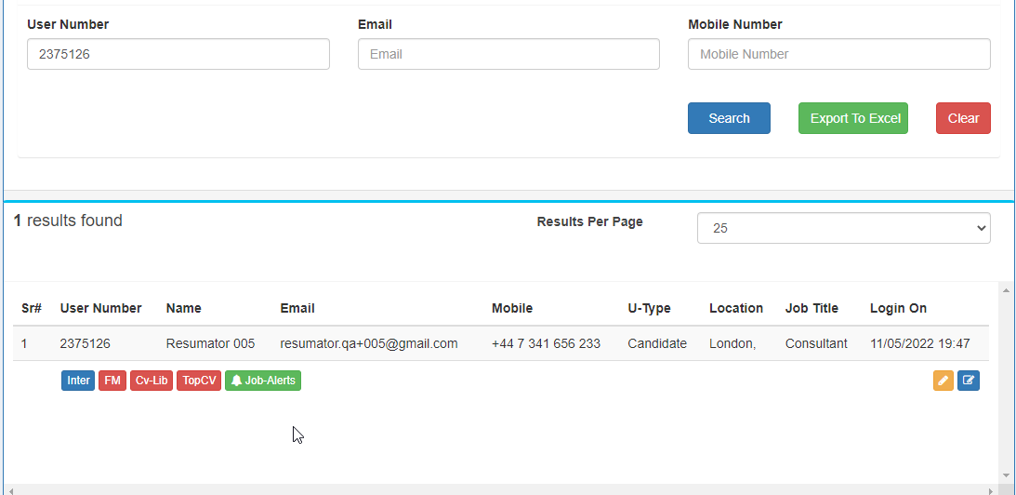
- https://secure.apply4u.co.uk/review/cmVzdW1hdG9yLnFhKzAwNUBnbWFpbC5jb20=
- USER ID = 2375126
- Enter Password
- Replace the CV
- Checked the both checkboxes
- Clicked Save Changes
- ISSUE: Application Crashed for me
- Tried to access the same link again
- ISSUE: Seeing page The page you are looking for no longer exists
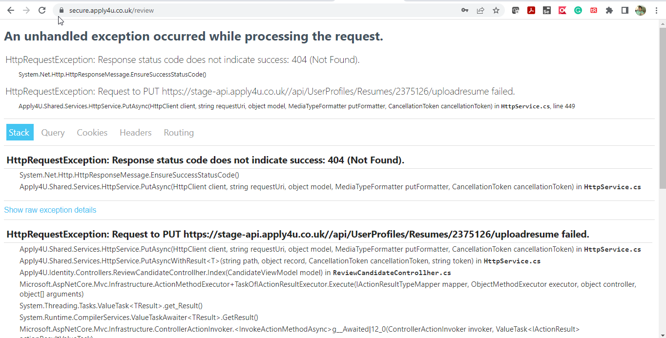

After Crash Admin View:
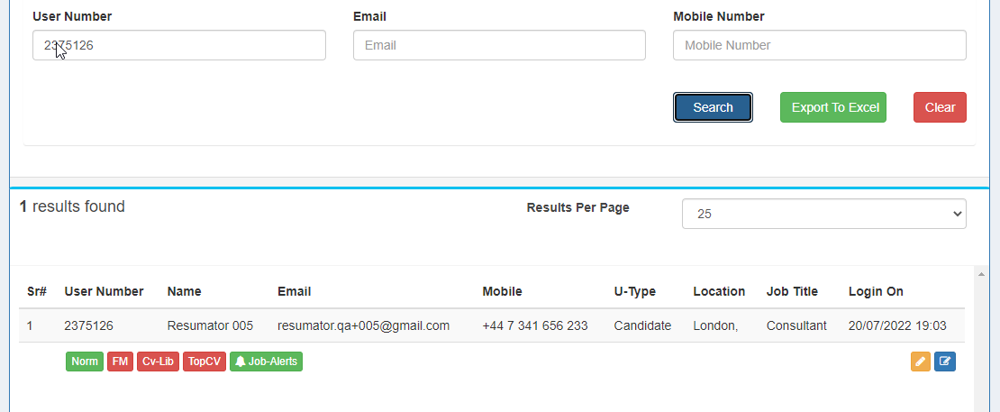

ISSUE :6 (Understanding issue)
- User ID / Link 2375125 / https://secure.apply4u.co.uk/review/cmVzdW1hdG9yLnFhKzAwNEBnbWFpbC5jb20=
- Within Admin section Top CV was already green against this use
Before Save Change
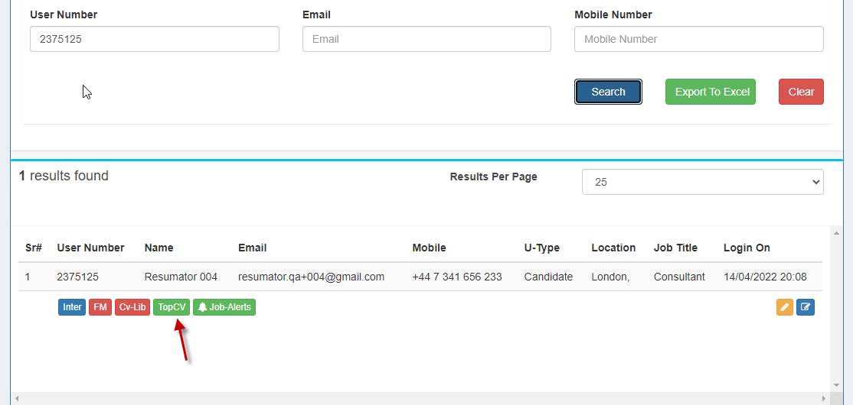
- I then completed the 1st step (Checked the both checkboxes) and 2nd step
- Refreshed the Admin -User Manager
- Inter changes to Normal and got Green GOOD
- ISSUE: Top CV changes from green to Yellow

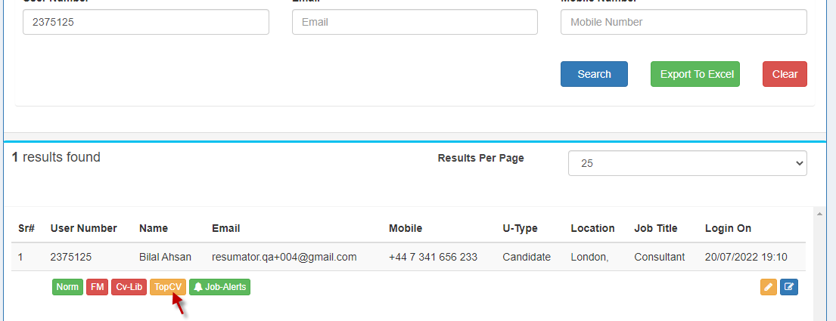
- Completed the Registration and entered the correct city/postcode/country and Ph #
- Completed
- ISSUE: CV Lib changes to yellow and should be green, I tried with several accounts
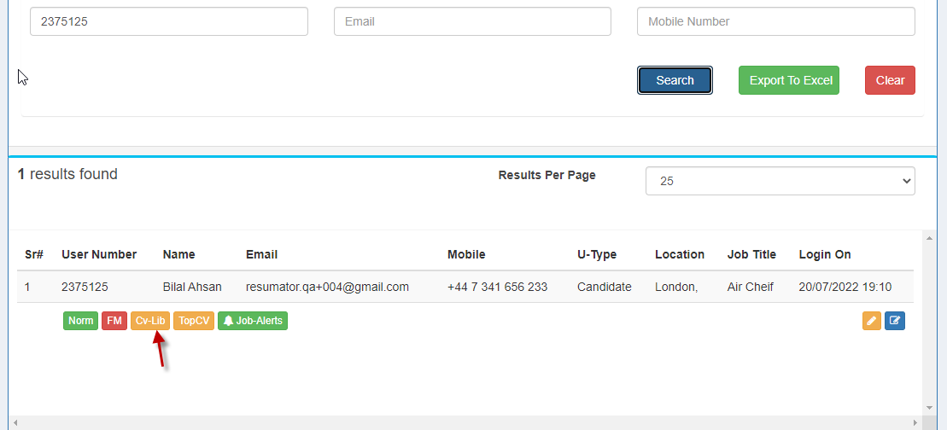

ISSUE: 7 Email Change (Fixed)
- Open the link
- On initial load you I see the below information
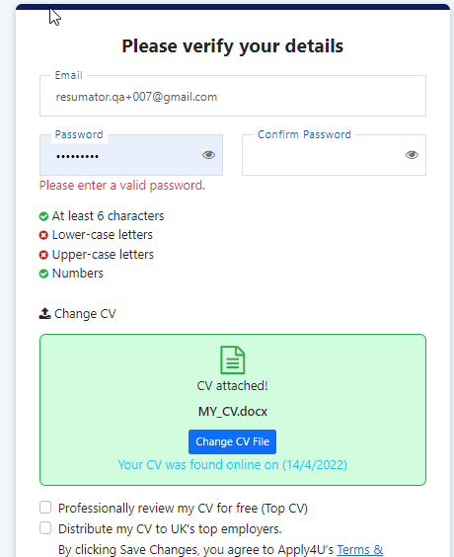
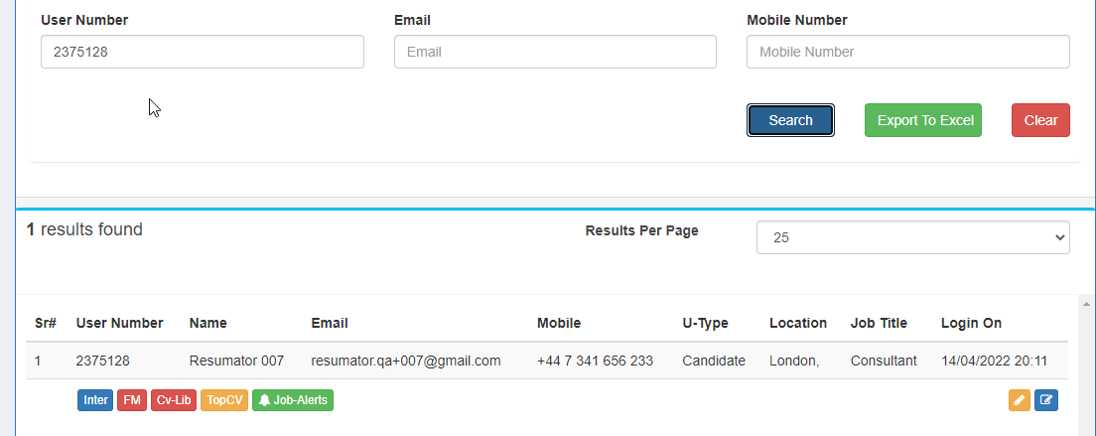
- I then changed the email address
- Entered pass
- Checked the both checkboxes
- Save change
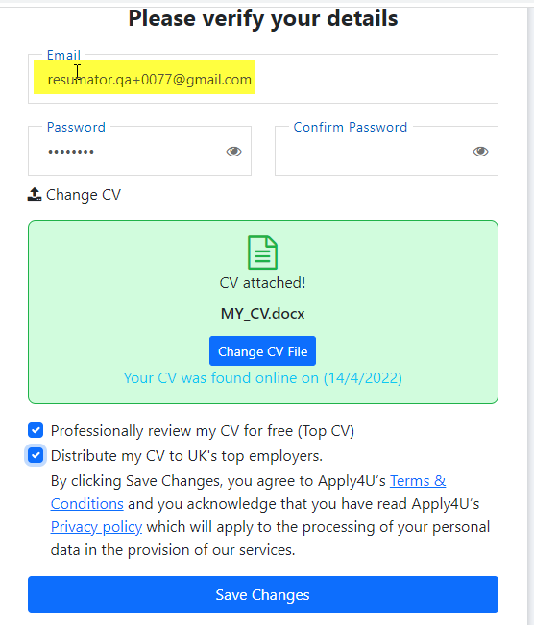
- ISSUE:1 Application sent me back on the 1st page again
- ISSUE #2: When I tried to search the candidate within admin section chasing circle remain on screen and I see no record found.

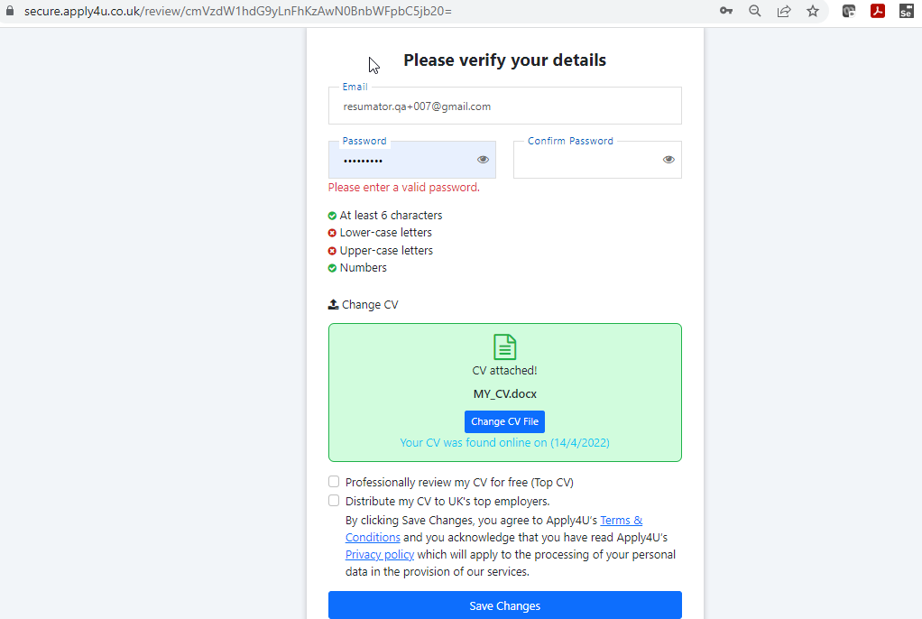
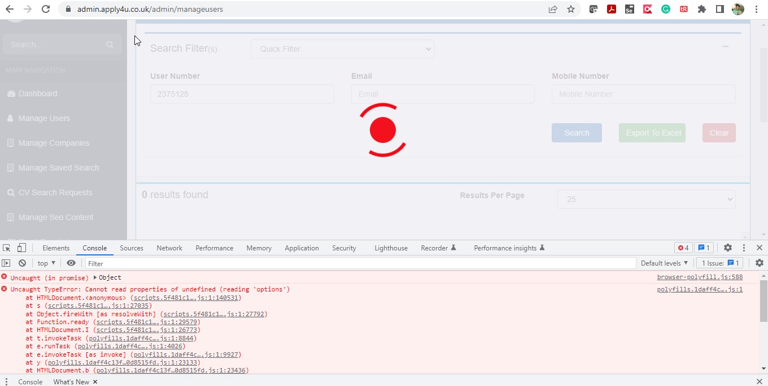
- I edited the email address again
- Clicked Save Changes button
- ISSUE: Then I see the below screen
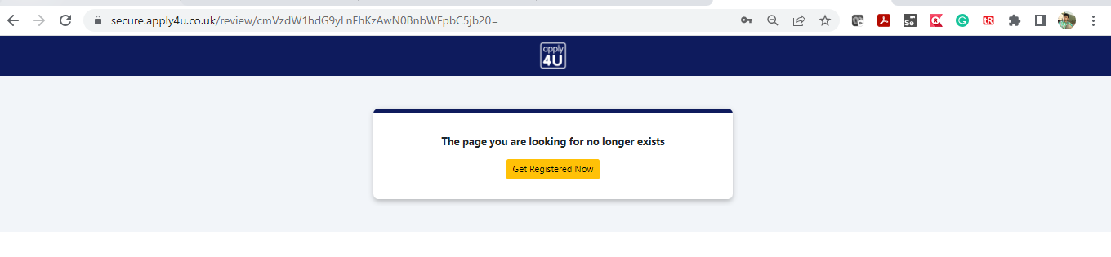

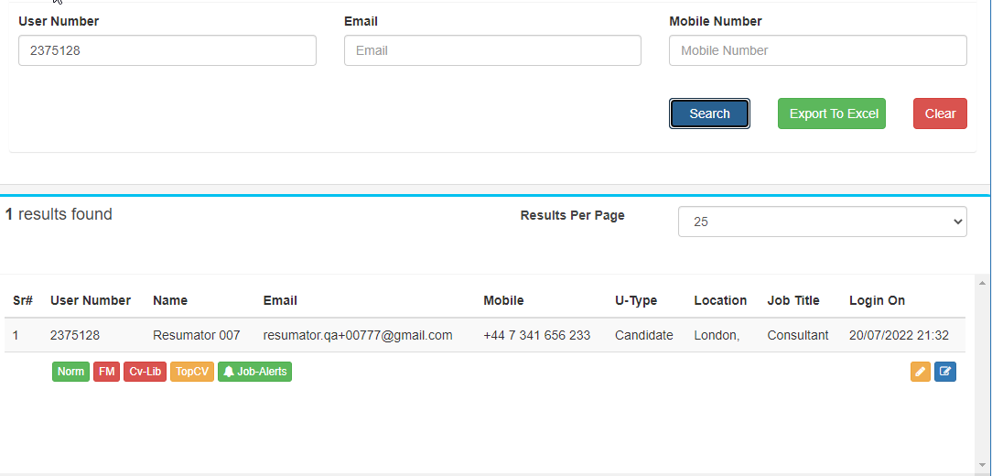

ISSUE:8
- Open link
- You should see the 1st page
- Edit the email address and enter email that already exist within out system (Normal candidate email)
- Save changes
- ISSUE: You will be redirected back to the 1st screen again and there is not validation or information for the user.
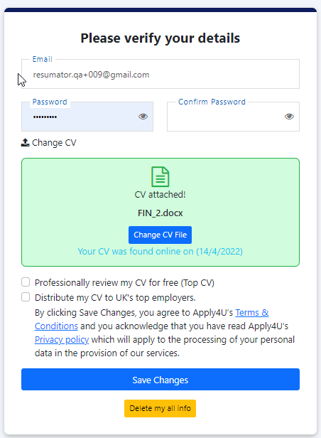

ISSUE:9 (Fixed)
- Open link
- Delete all my information
- ISSUE: You should see application crashed
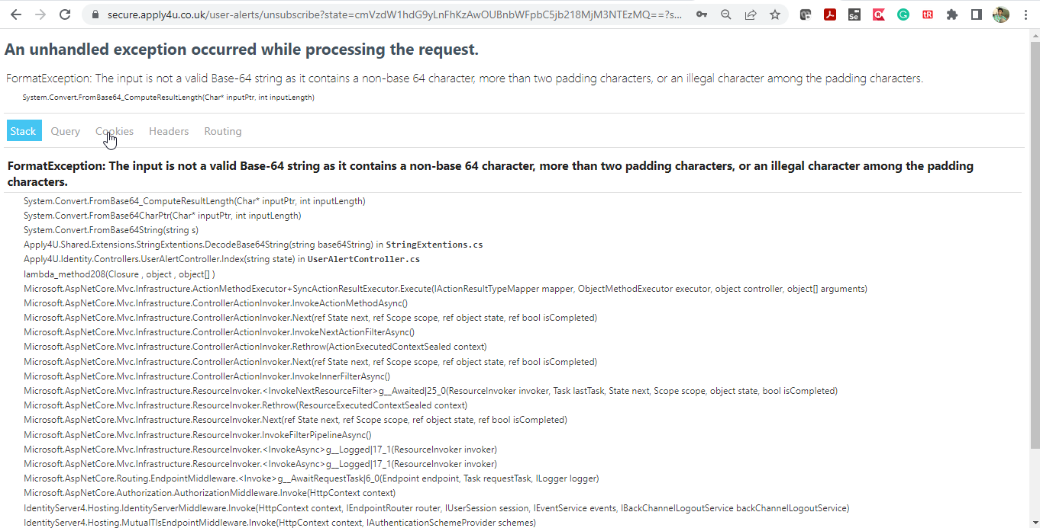

ISSUE: 10
- Open the link in two tabs
- Complete the registration from 1st tab
- Now switch over to the 2nd tab
- Enter pass
- Click on Save changes
- ISSUE: Application says This page isn’t working and there should be some validation check

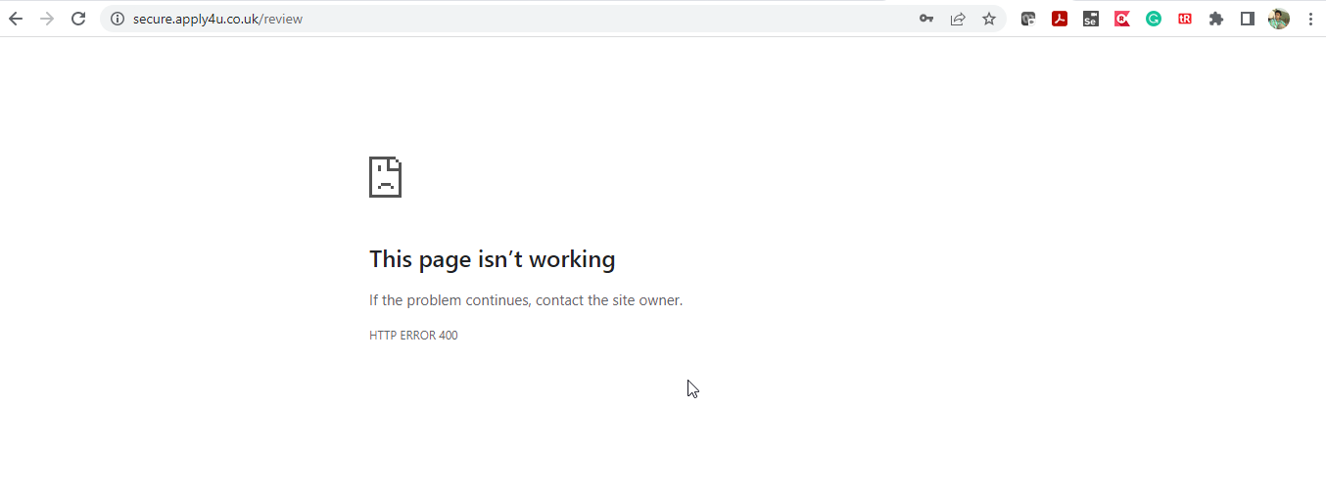

ISSUE: 11
- if CV Distribute is unchecked and completed the flow, the CV LIB should be yellow
- ISSUE: In my case when CV LIB was red and I completed the registration by unchecking the Distribute CV check box, it is remained red and as per our discussion should be yellow

