Bug Report

Issue 1:
In the breadcrumb section of the recruiter account the second last link is not clickable.
https://www.apply4u.co.uk/cv-search/costs-lawyer-cvs-in-netherne-on-the-hill-coulsdon-surrey/1589398
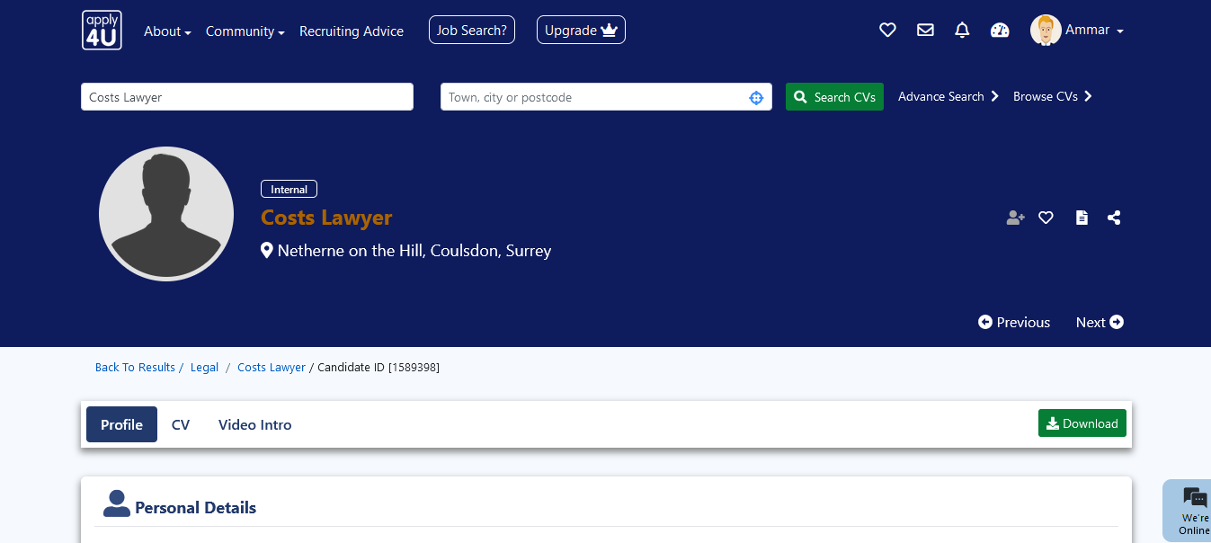

https://www.apply4u.co.uk/cv-search/assistant-lecturer-cvs-in-ilford-london/2906926
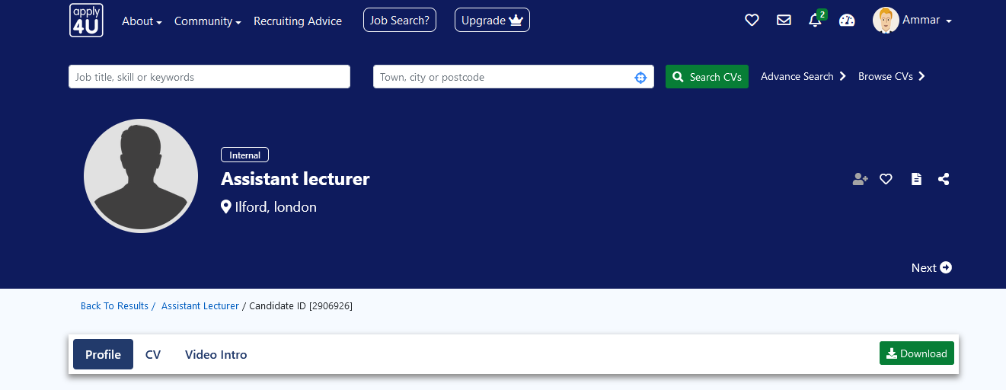

Issue 2:
Package name user is not showing details in recruiter package.
