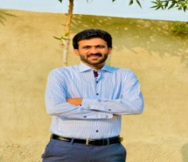
AMIR SAOOD
Mob: +92300-6647913
Address: Lashrian Tehsil & Dist Okara:
Email:amirkhanlasharibaloch@gmail.com

OBJECTIVE

To obtain a position of responsibility at an organization that provides a professional working environment, where I can utilize my knowledge, various skills & experience in contribution towards fulfilling the company’s growth objectives, develop my career and excel in the related field.

SKILLS

Successfully working skills on the following:
- C, C++
- Contents writing
- Social networking
- Good analytical skills
- Creative and positive attitudes
- Leadership and management skills

SOFTWARES SKILLS

- Visual Studio
- Notepad++
- MS Office

EDUCATION HISTORY

2015 – 2019 Mechanical Engineering Technology (Bsc)
Govt College University Faisalbad

2012 – 2015 Diploma in Associate engineering
BISE Lahore

2010 – 2012 SSC
BISE Lahore

FINAL YEAR PROJECT

As my Final Year Project, I developed a project named “Wind Turbine. This Project provides a way of solving the problems.
Tools: Drivetrain efficiency prediction and optimization Handler.
Role: The most Complete Simulation Platform for engineering and certify the next generation of integrated wind turbine drivetrains.
Duration: 6 Months approximately.
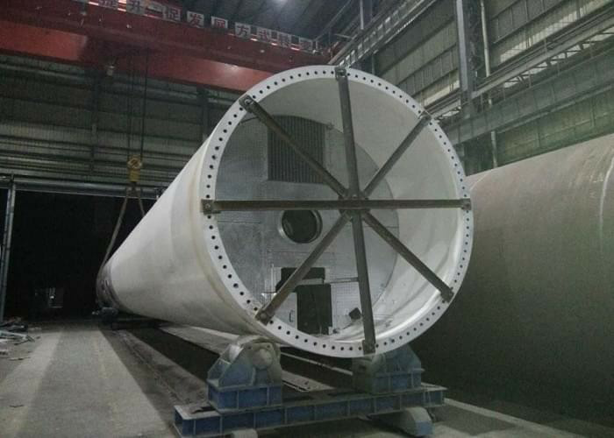
Final Project:

PERSONAL PROFILE

Date of Birth : 02-02-1995
Religion : Islam
CNIC #. : 35303-0527908-5
Marital Status : Single
Gender : Male

LANGUAGES
- English
- Urdu
- Punjabi

REFERENCE

References, recommendations and appreciation letters are available on request

