Our Technology
ISSUE 88
- Spacing issue
- Header text is bold in desktop view but in responsive it is not.

Frequently Asked Questions
ISSUE 89
- When you expand any section and then expand another – It will collapse the previously expanded one see the arrow direction in this case.

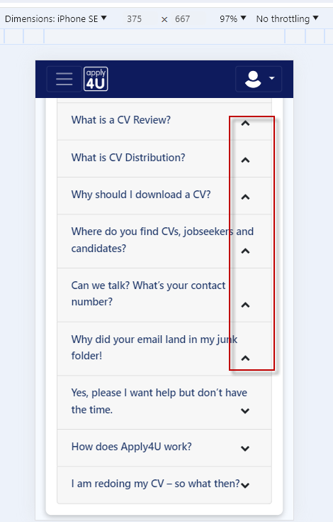
ISSUE 90
- Where the expander text shift over to end line arrow icon also shift over to 2nd line – can we stick this arrow within top row where text end?
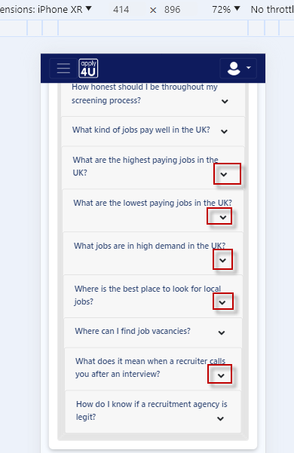
Contact US
ISSUE 91
- In some responsive view contact information is very close to the boundary line
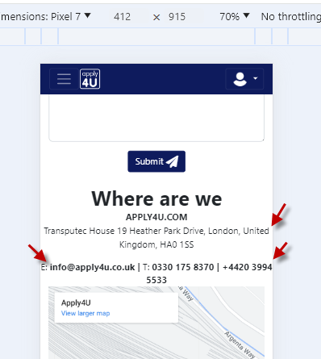
ISSUE 92
- In some responsive view contact us screen is not center aligned
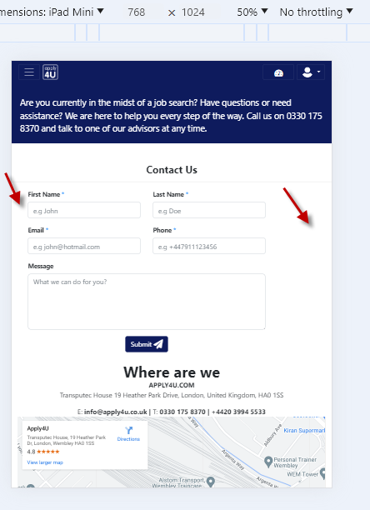
Carrer Advice
ISSUE 93
- Remove underline from links – Should only display when you hover over.

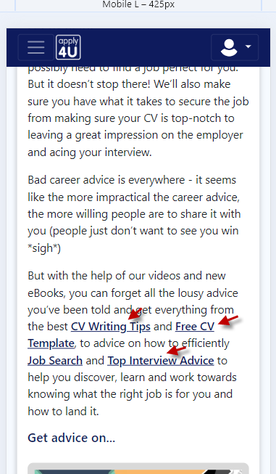
ISSUE 94:
- Not able to load the Blogs images when you shift over to any page and revisit
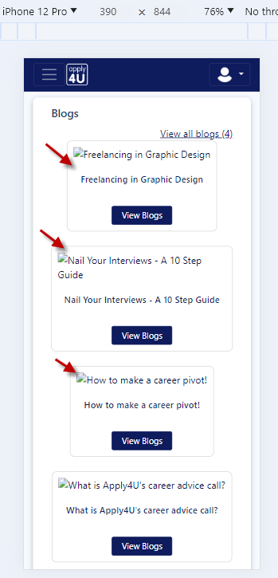
User Directory
ISSUE 95
- Can we adjust the bread crumb within a single in some responsive views?
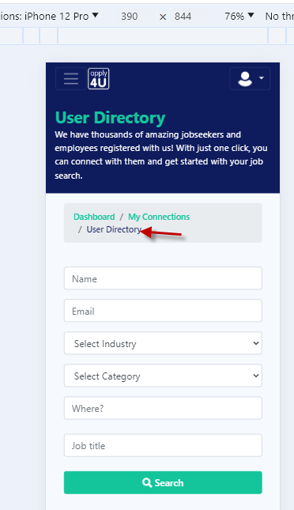
ISSUE 96
- When you expand the drop down its crossing the responsive view boundary lines
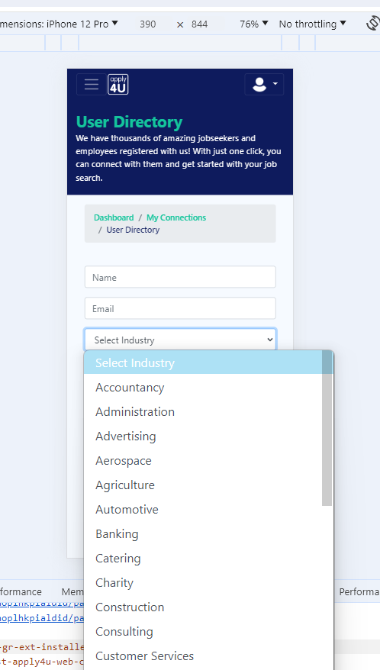
Groups and Forum
ISSUE 97
- Button and overlaps.

Pricing

ISSUE 98
- Pricing page mobile view

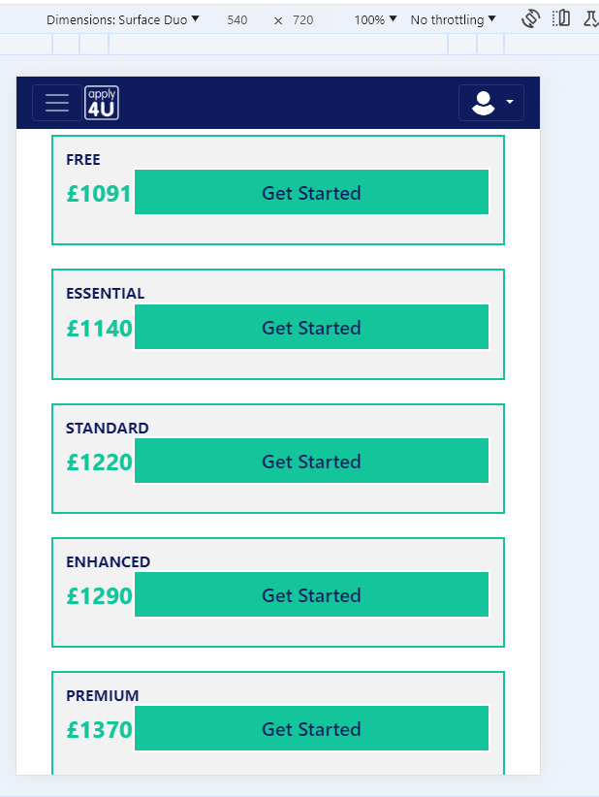

ISSUE 99
- Pricing Page – Get Started
  - Alignment

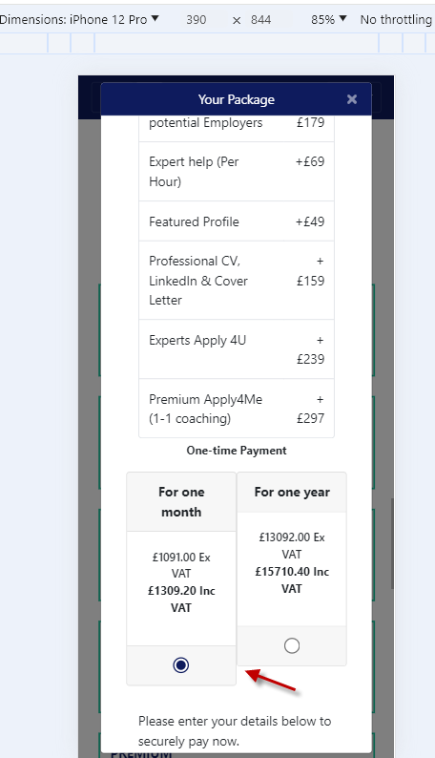

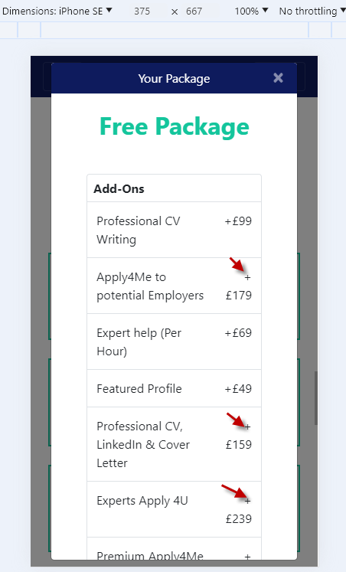
ISSUE 100

- Spacing issue
